MINISTRY OF EDUCATION AND SCIENCE OF UKRAINE

NATIONAL TECHNICAL UNIVERSITY   
“KHARKIV POLYTECHNIC INSTITUTE”

Department of Software Engineering and Management Information Technology

REPORT

on laboratory work # 1

on the discipline

“DESIGN OF DATABASES”

Executed by

Student of the group KN-218g

chukwu irele

Checked by

Assoc. prof. of department “SEMIT”

PhD assoc. prof.

Дмитрий Двухглавов

Kharkiv 2020

**DATA MANIPULATION USING SQL LANGUAGE TOOLS: INSERT,**

**UPDATE, AND DELETE**

Objectives

learn how to use SQL language operators to add, update, and delete

data in MySQL DBMS.

**Adding data to a created database:**

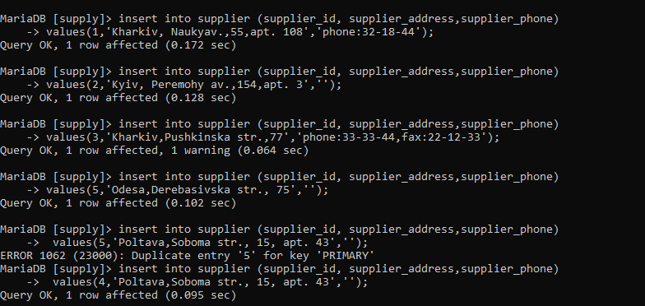

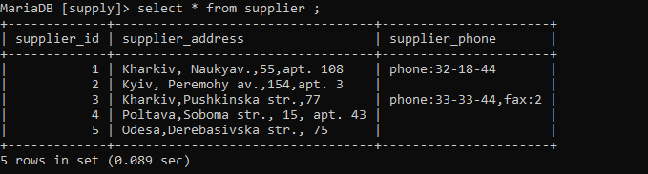

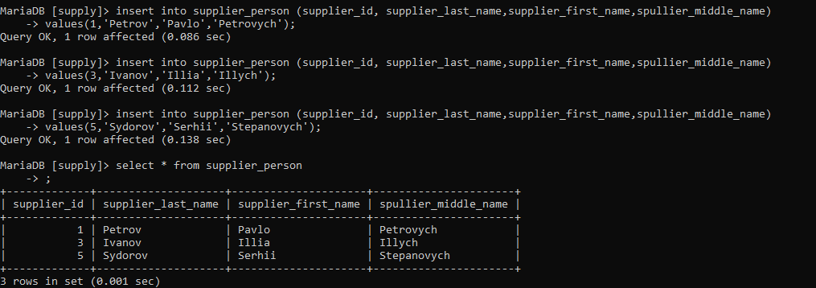

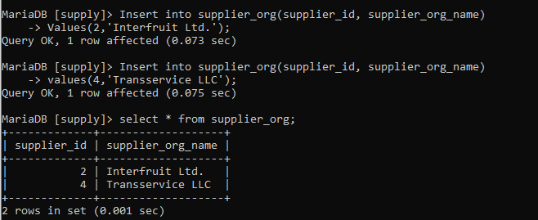

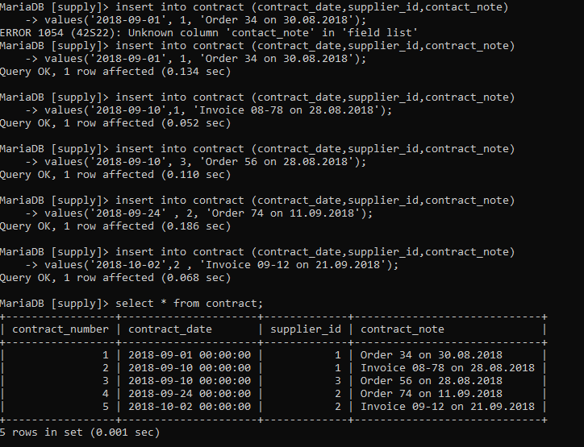

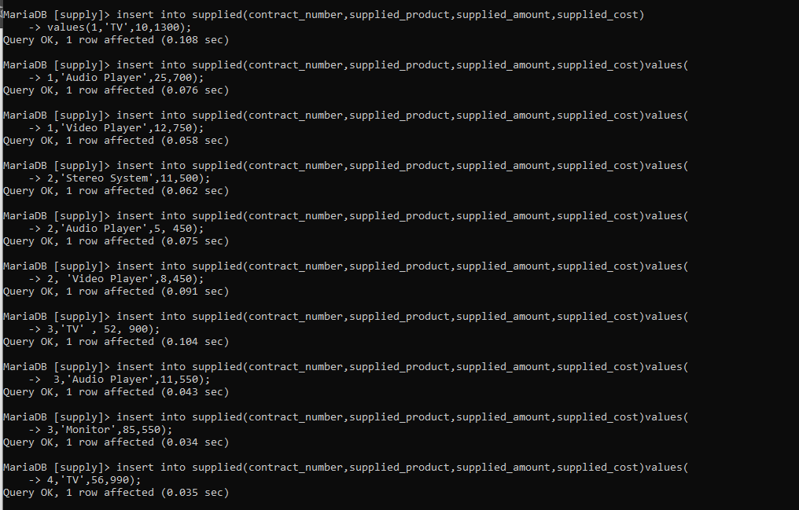

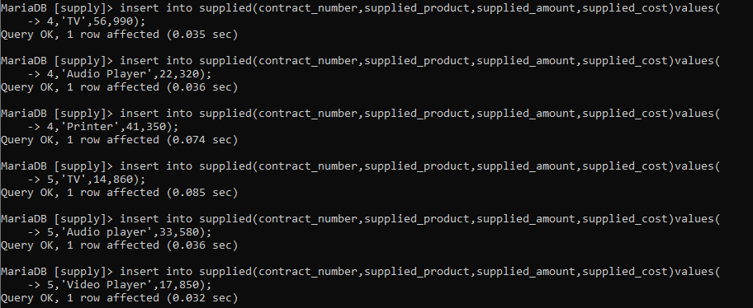

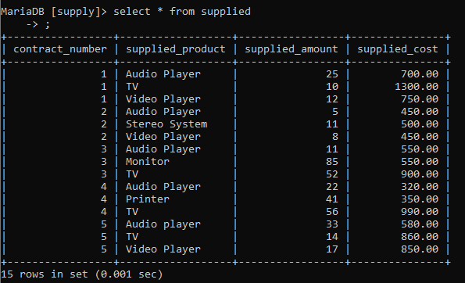

**Database update:**

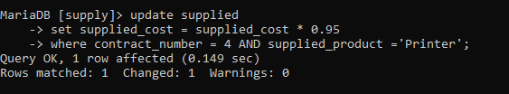

**Deleting data from a database:**

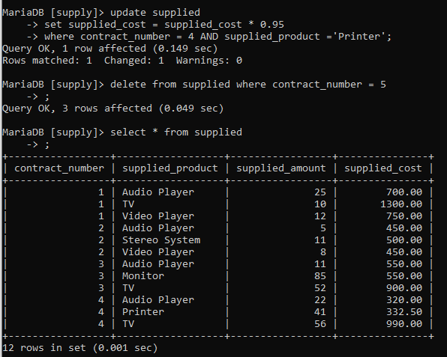

Conclusions

In conclusion :

1. I obtained skills for Data Manipulation with SQL Language tools: INSERT ,UPDATE and DELETE.
2. Inserted data into tables created in previous lab using SQL INSERT tool.
3. Also using the UPDATE tool update a field in a table.
4. Lastly using the DELETE tool deleted record from a table with a certain criteria